EMG-Based Rehabilitation Gaming System for
Gesture Training and Performance Evaluation

Project Report

Submitted in partial fulfilment of the requirements for the award of the degree of
Bachelor of Technology
in
Electrical Engineering
By
POTTURI SUMANTH (Roll No.: B230493EE)
TAMMIREDDY VARDHAN (Roll No.: B231280EE)
UPPULURI SAI TEJASWI (Roll No.: B231305EE)
VISHWADEEP K V (Roll No.: B231335EE)


Department of Electrical Engineering
NATIONAL INSTITUTE OF TECHNOLOGY CALICUT
NIT CAMPUS P.O.
May 2026
CERTIFICATE

This is to certify that the report entitled “EMG-Based Rehabilitation Gaming System for Gesture Training and Performance Evaluation” is a Bonafide record of the Project done by TAMMIREDDY VARDHAN (Roll No.: B231280EE), UPPULURI SAI TEJASWI (Roll No.: B231305EE), VISHWADEEP K V(Roll No.: B231335EE) and POTTURI SUMANTH (Roll No.: B230493EE) under my supervision, in partial fulfilment of the requirements for the award of the degree of Bachelor of Technology in Electrical Engineering from National Institute of Technology Calicut, and this work has not been submitted elsewhere for the award of a degree.

Dr. Sanjay M
(Guide)
Assistant Professor
Dept. of Electrical Engineering

Professor & Head
Dept. of Electrical Engineering
Place : NIT Calicut
Date : May 2026

ACKNOWLEDGEMENT

We would like to express our sincere gratitude to Dr. Sanjay M, Assistant Professor, Department of Electrical Engineering, National Institute of Technology Calicut, for his guidance, encouragement, and valuable suggestions throughout the course of this project. His insights into biomedical signal processing and embedded systems were instrumental in shaping the direction of this work.

We are also grateful to the faculty members and staff of the Department of Electrical Engineering for providing us access to the laboratory facilities and equipment required for hardware development and testing.

Finally, we thank our families and friends for their continued support and motivation during the course of this project.

POTTURI SUMANTH
TAMMIREDDY VARDHAN
UPPULURI SAI TEJASWI
VISHWADEEP K V

ABSTRACT

Electromyography (EMG) is a biomedical technique used to measure the electrical activity generated by skeletal muscles during contraction. Surface EMG (sEMG), being non-invasive, enables real-time acquisition of muscle activity signals and is widely used in rehabilitation and human–machine interaction systems. The recorded signal represents the superimposed Motor Unit Action Potentials (MUAPs) from active motor units.
This project presents the design and development of an EMG-based rehabilitation gaming system aimed at improving upper-limb therapy engagement. Conventional rehabilitation methods often suffer from low patient adherence due to repetitive and monotonous exercises. To address this limitation, the proposed system integrates sEMG signal processing with an interactive game-based environment to enhance user motivation while maintaining therapeutic effectiveness.
The system consists of an analog front-end for signal conditioning, an ESP32 microcontroller for signal acquisition, and a machine learning pipeline for gesture classification. The EMG signal is preprocessed, segmented into time windows, and transformed into statistical features such as RMS and mean absolute value. A K-Nearest Neighbors (KNN) classifier is used to distinguish between rest, flexion, and extension gestures, achieving an accuracy of approximately 80%. The classified gestures are mapped to a graphical interface, providing real-time feedback and stable interaction through additional filtering and decision logic.
The results demonstrate the feasibility of integrating embedded systems, signal processing, and machine learning to create an effective and reliable rehabilitation platform.

CONTENTS
List of Abbreviations iii
List of Figures iv
1 INTRODUCTION 1
1.1 Background of the Project 1
1.2 Motivation for the Project 1
1.3 Problem Statement 2
1.4 Objectives of the Project 3
1.5 Summary of the Report 3
2 REVIEW OF LITERATURE 4
2.1 EMG in Rehabilitation 4
2.2 Gamification of Rehabilitation 5
2.3 Machine Learning for Gesture Classification 6
3 PROPOSED METHODOLOGY 7
3.1 Overview of the Proposed System 7
3.2 System Architecture 8
3.3 Working Principle 9
4 FUNCTIONAL DESCRIPTION OF THE SYSTEM 10
4.1 System Functionality 10
4.2 Operational Workflow 10
4.3 Key Features of the Proposed System 12
5 HARDWARE IMPLEMENTATION 13
5.1 Hardware Components Used 13
5.2 Description of Components 13
5.3 Circuit Design 15
5.4 Hardware Architecture 17
6 SOFTWARE IMPLEMENTATION 18
6.1 Software Tools and Platforms 18
6.2 Algorithm and Program Flow 18
6.3 Summary of Software Implementation 19
7 RESULTS AND DISCUSSION 20
7.1 ML Pipeline Demonstration 20
7.2 Module Data VIsualisation 22
7.3 RAW EMG Signal From Biopac 23
8 CONCLUSION AND FUTURE SCOPE 24
8.1 Conclusion 24
8.2 Future Scope 25
APPENDIX 26
REFERENCES 30

LIST OF ABBREVIATIONS

ADC Analog-to-Digital Converter
AFE Analog Front-End
ARV Average Rectified Value
CMRR Common-Mode Rejection Ratio
DSP Digital Signal Processing
EMG Electromyography
ESP32 Espressif Systems ESP32 Microcontroller
MFCV Muscle Fiber Conduction Velocity
MUAP Motor Unit Action Potential
MVC Maximum Voluntary Contraction
NMJ Neuromuscular Junction
PCB Printed Circuit Board
RMS Root Mean Square
sEMG Surface Electromyography
SVM Support Vector Machine
KNN K-Nearest Neighbours
MAV Mean Absolute Value
DAQ Data Acquisition
PC Personal Computer
CSV Comma-Separated Values
LOFO Leave-One-File-Out (validation method)
Hz Hertz (frequency unit)
Vpp Peak-to-Peak Voltage
SNR Signal-to-Noise Ratio
ISI Inter-Symbol Interference
FFT Fast Fourier Transform
PDF Probability Density Function
GUI Graphical User Interface
LIST OF FIGURES
1.1: Typical raw EMG signal from upper limb muscles |  | 2
3.1: System flowchart showing the complete EMG-based rehabilitation pipeline |  | 7
4.1: KNN Gesture Classification |  | 11
5.1: Muscle Sensor v3 module used as the analog front-end for EMG acquisition |  | 14
5.2: Analog front-end simulation circuit (instrumentation amplifier, bandpass filter, notch filter, final stage amplifier) |  | 16
5.3: Oscilloscope output of the EMG sensor module showing muscle activation waveform (Vpp=1.06V, Vmax=2.02V) |  | 17
7.1: EMG Hardware Gesture Replay launcher application |  | 21
7.2: EMG Gesture Control window showing Turtle in rest state with confidence 1.00. |  | 21
7.3: Post-session terminal log showing timestamped predicted gestures with confidence and margin values. |  | 22
7.4: Confusion matrix showing classification results across 144 validation windows. |  | 22
7.5: Rectified and filtered EMG signal vs. time, showing distinct activation spikes during gestures. |  | 23
7.6: Raw EMG signal (red) and RMS envelope (blue) captured in AcqKnowledge for reference. |  | 23
A1: EMG Feature Extraction Function |  | 26
A.2: Z-Score Normalization and Feature Scaling |  | 26
A.3: Distance-Weighted KNN Classification Algorithm  A.4: ESP32-based real-time EMG signal acquisition and serial data transmission setup |  | 27  28
A.5: Python-based EMG data visualization from CSV using Pandas and Matplotlib |  | 29

CHAPTER 1
INTRODUCTION
1.1 BACKGROUND OF THE PROJECT
Electromyography (EMG) is a technique used to measure the electrical activity produced by skeletal muscles during contraction. The signal originates from Motor Unit Action Potentials (MUAPs), which are generated when motor neurons activate groups of muscle fibres. At the skin surface, the recorded signal represents the combined activity of multiple motor units, commonly referred to as surface electromyography (sEMG) [1].
Surface EMG is a non-invasive method in which electrodes placed on the skin detect differential voltage signals. These signals typically have amplitudes in the range of microvolts and occupy a frequency band approximately between 10 Hz and 500 Hz, requiring amplification and filtering before further processing [1][2].
With the advancement of embedded systems and signal processing techniques, EMG-based systems have been increasingly applied in rehabilitation monitoring, prosthetic control, and gesture-based human–machine interfaces [2][3]. These developments have enabled the use of EMG signals in real-time applications where muscle activity can be translated into control commands. This project builds on these concepts to develop an EMG-based system for interactive rehabilitation.
1.2 MOTIVATION FOR THE PROJECT
Neurological conditions such as stroke often impair upper-limb motor function, making repetitive rehabilitation exercises essential for recovery. However, conventional therapy methods are monotonous and provide limited real-time feedback, which often leads to reduced patient motivation and inconsistent participation [1].
Surface EMG enables direct measurement of muscle activity and can be used as a feedback mechanism to guide patient effort. When combined with simple interactive interfaces, it can make rehabilitation more engaging while still maintaining clinical relevance [4]. This motivates the development of a low-cost EMG-based system that integrates physiological signal processing with real-time user interaction.
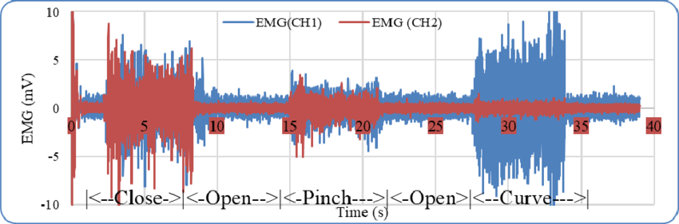
Figure 1.1: Typical raw EMG signal from upper limb muscles
(Adapted from “Implementation of Supervised Machine Learning on Embedded Raspberry Pi System to Recognize Hand Motion as Preliminary Study for Smart Prosthetic Hand,” ResearchGate, 2023.)
1.3 PROBLEM STATEMENT
Conventional rehabilitation systems are limited by the lack of objective feedback and low patient engagement. Patients often perform repetitive movements without clear indicators of performance quality, while therapists have limited access to continuous quantitative data for assessment.
In addition, EMG-based systems present technical challenges such as low signal amplitude, sensitivity to noise, inter-subject variability, and the complexity of real-time classification of muscle activity [2].
Therefore, there is a need for a system that can:
- Acquire and process sEMG signals reliably under real-world conditions
- Extract meaningful features from noisy biological signals
- Classify user intent accurately in real time
- Provide stable and responsive interaction through a user interface
- Log performance metrics for clinical evaluation
This project addresses these challenges through an integrated hardware–software pipeline combining signal conditioning, embedded processing, machine learning-based classification, and interactive feedback.
1.4 OBJECTIVES OF THE PROJECT
The objectives of this project are:
(i) Signal Acquisition:To acquire surface EMG signals from forearm muscles corresponding to wrist gestures.
(ii) Signal Processing:To preprocess and segment the signals and extract relevant features for classification.
(iii) Gesture Classification:To implement a machine learning model for real-time classification of rest, flexion, and extension.
(iv) User Interaction:To develop an interface that maps gestures to visual actions and provides immediate feedback.
(v) Performance Evaluation:
To evaluate system accuracy and robustness under practical conditions.
1.5 SUMMARY OF THE REPORT
The remainder of this report is organized as follows. Chapter 2 presents a review of relevant literature on EMG-based rehabilitation systems, signal processing techniques, and gesture classification methods. Chapter 3 describes the proposed methodology and system architecture. Chapter 4 details the functional operation of the system. Chapters 5 and 6 discuss the hardware and software implementation respectively. Finally, the results, conclusions, and future scope of the work are presented.

CHAPTER 2
REVIEW OF LITERATURE
This chapter reviews prior work relevant to the proposed system in three key areas: the use of surface electromyography (sEMG) in rehabilitation, the role of gamification in improving therapy outcomes, and machine learning techniques for EMG-based gesture classification.
2.1 EMG IN REHABILITATION
Surface EMG (sEMG) has been widely used as a non-invasive tool for monitoring muscle activity in clinical rehabilitation. McManus et al. [1] present a detailed analysis of the physiological basis of EMG signal generation and highlight its effectiveness as a biofeedback mechanism. They show that even simple processing methods such as RMS estimation and signal onset detection can provide meaningful insights into muscle activation patterns. Such feedback enables patients to better control muscle activity and improve coordination during rehabilitation exercises.
The authors further emphasize that real-time visual feedback based on sEMG signals can enhance motor learning and improve functional outcomes in patients with neurological impairments [1]. This establishes sEMG as not only a diagnostic tool but also an active component in therapy.
From a system design perspective, the acquisition chain described by McManus et al. [1]—including bipolar electrode configuration, high-gain differential amplification, and band-pass filtering—directly informs the hardware design of the present work. In addition, they recommend sampling rates of at least 1 kHz to accurately capture EMG signal characteristics.
Sul et al. [2] extend this work by presenting a complete EMG signal acquisition and processing pipeline for real-time applications such as exoskeleton control. Their study highlights the importance of noise reduction techniques, proper electrode placement, and differential amplification to ensure reliable signal quality. These considerations are directly reflected in the signal conditioning and acquisition stages of the proposed system.
2.2 GAMIFICATION OF REHABILITATION
In recent years, gamification has emerged as an effective approach to address the problem of low patient engagement in rehabilitation. By introducing interactive elements and visual feedback, therapy sessions can be made more engaging and goal-oriented.
Santos Pessoa de Melo et al. [5] developed an EMG-controlled virtual reality rehabilitation system and observed improved user engagement and task completion rates compared to conventional therapy. Their findings suggest that immersive environments can encourage consistent participation and enhance motivation.
Similarly, Vo Duy [6] proposed a wrist rehabilitation device integrated with an interactive game interface. The study reported increased patient engagement, longer therapy durations, and improved satisfaction levels when compared to traditional exercise methods.
Oña et al. [4] conducted a study on EMG-controlled video games for upper-limb rehabilitation and demonstrated measurable improvements in motor function among patients with neurological conditions. The study concluded that combining physiological signal feedback with interactive gameplay can significantly enhance rehabilitation outcomes.
These works collectively highlight the effectiveness of gamification in rehabilitation and support the design choice of incorporating an interactive feedback system in the proposed project.
2.3 MACHINE LEARNING FOR GESTURE CLASSIFICATION
Traditional EMG-based control systems often rely on simple thresholding techniques to detect muscle activation. While suitable for basic applications, these methods are highly sensitive to noise and variations in signal characteristics due to factors such as electrode placement and user-specific differences.
To overcome these limitations, machine learning approaches have been widely adopted for EMG-based gesture classification. Sul et al. [2] discuss the use of classifiers such as Support Vector Machines (SVM) for distinguishing between different muscle activation patterns, emphasizing their ability to operate efficiently in real-time systems.
Feature extraction plays a critical role in classification performance. Commonly used time-domain features include root mean square (RMS), mean absolute value (MAV), and waveform length, while frequency-domain features capture spectral characteristics of the EMG signal. These features help in representing complex muscle activity patterns in a compact and discriminative form.
Farina et al. [7] provide a detailed explanation of the physiological and biophysical factors that influence EMG signal characteristics, including amplitude variation and frequency content. Their work supports the selection of appropriate features for classification and highlights the importance of understanding signal properties during system design.
Overall, the literature indicates that combining reliable signal acquisition with appropriate feature extraction and machine learning techniques can significantly improve the accuracy and robustness of EMG-based gesture recognition systems.

CHAPTER 3
PROPOSED METHODOLOGY
3.1 OVERVIEW OF THE PROPOSED SYSTEM
The proposed system acquires surface EMG (sEMG) signals from the forearm muscles during voluntary wrist movements and converts them into control commands for an interactive interface. The system was initially prototyped using a commercial EMG sensor module interfaced with a microcontroller and a simple threshold-based control scheme. This preliminary setup demonstrated that muscle activity could be reliably mapped to on-screen actions.
The final system extends this approach by incorporating a structured signal processing and machine learning pipeline. A custom acquisition setup is used to obtain EMG signals, which are processed and classified in real time to distinguish between rest, flexion, and extension gestures. The classified output is then used to control a graphical interface, providing immediate feedback to the user.
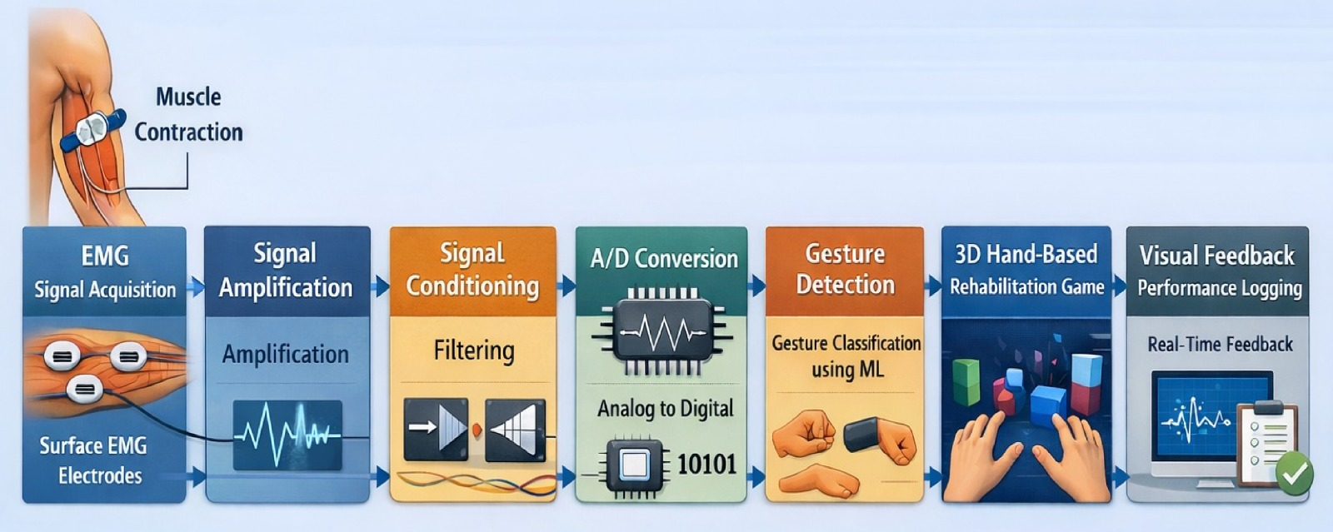
Figure 3.1: System flowchart showing the complete EMG-based rehabilitation pipeline

3.2 SYSTEM ARCHITECTURE
The system is organized into three main stages: signal acquisition and conditioning, digital processing and classification, and the application interface.
3.2.1 Analog Front-End (AFE)
Surface electrodes are placed over the forearm muscles responsible for wrist movement. The EMG signal, which is of low amplitude and susceptible to noise, is conditioned using amplification and filtering stages. Differential amplification is employed to reduce common-mode noise, particularly power-line interference.
A band-pass filtering stage is used to retain the relevant EMG frequency components, typically within the range of 20 Hz to 500 Hz [1][2]. The conditioned signal is then made suitable for digitization.
3.2.2 Digitization and Classification
The conditioned analog signal is sampled using a microcontroller at an adequate sampling rate to capture the EMG signal characteristics. The acquired signal is then processed in real time using a software pipeline.
The signal is first normalized and segmented into overlapping time windows. For each window, statistical features such as mean absolute value (MAV), root mean square (RMS), and standard deviation are extracted. These features represent the muscle activation pattern within that time segment.
A K-Nearest Neighbours (KNN) classifier is used to classify each window into one of three states: rest, flexion, or extension. The classifier operates on feature vectors and uses distance-based comparison with previously recorded training data to determine the closest matching gesture.

3.2.3 Application Layer
The classified gesture output is mapped to actions in a graphical interface developed using Python. The interface responds to user gestures by triggering visual movements, providing immediate feedback.
To improve stability, additional decision logic is implemented to reduce false triggering due to noise or weak signals. The system responds only to consistent gesture predictions over a short time interval, ensuring smoother interaction.
3.3 WORKING PRINCIPLE
When a user performs a wrist movement, electrical activity generated by muscle contraction is detected by surface electrodes as an EMG signal. This signal is amplified and filtered to remove noise and unwanted frequency components.
The processed signal is digitized and divided into short time windows. Within each window, features such as RMS and mean absolute value are computed to characterize the signal.
These features are then fed into a trained KNN classifier, which compares them with stored reference patterns and determines the corresponding gesture. Based on the classified output, the graphical interface is updated, allowing the user to interact with the system in real time.

CHAPTER 4
FUNCTIONAL DESCRIPTION OF THE SYSTEM
4.1 SYSTEM FUNCTIONALITY
The primary function of the system is to convert voluntary upper-limb muscle activity into corresponding actions in an interactive graphical interface. The system focuses on wrist flexion and extension, as these movements are commonly targeted in upper-limb rehabilitation.
For each session, the system continuously monitors muscle activity, classifies the detected gesture, and determines whether a valid movement has been performed. Successful gestures are translated into visual actions, allowing the user to interact with the interface in real time.
In addition to gesture control, the system records basic performance metrics such as repetition count and activity duration. This enables objective tracking of user performance over time, which can assist in evaluating rehabilitation progress.
4.2 OPERATIONAL WORKFLOW
The operation of the system is divided into three stages: calibration, real-time processing, and feedback.
4.2.1 Calibration Phase
Due to variability in EMG signals caused by factors such as electrode placement, skin conditions, and muscle strength, a short calibration step is performed at the start of each session. The user is asked to remain at rest to establish a baseline signal level, followed by performing a few sample gestures.
These initial recordings are used to normalize the signal and ensure that the classification model operates within an appropriate range for the user. This improves consistency and reduces misclassification during operation [2].
4.2.2 Real-Time Processing
During operation, the EMG signal is continuously acquired and segmented into short overlapping windows. For each window, features such as root mean square (RMS) and mean absolute value (MAV) are computed.
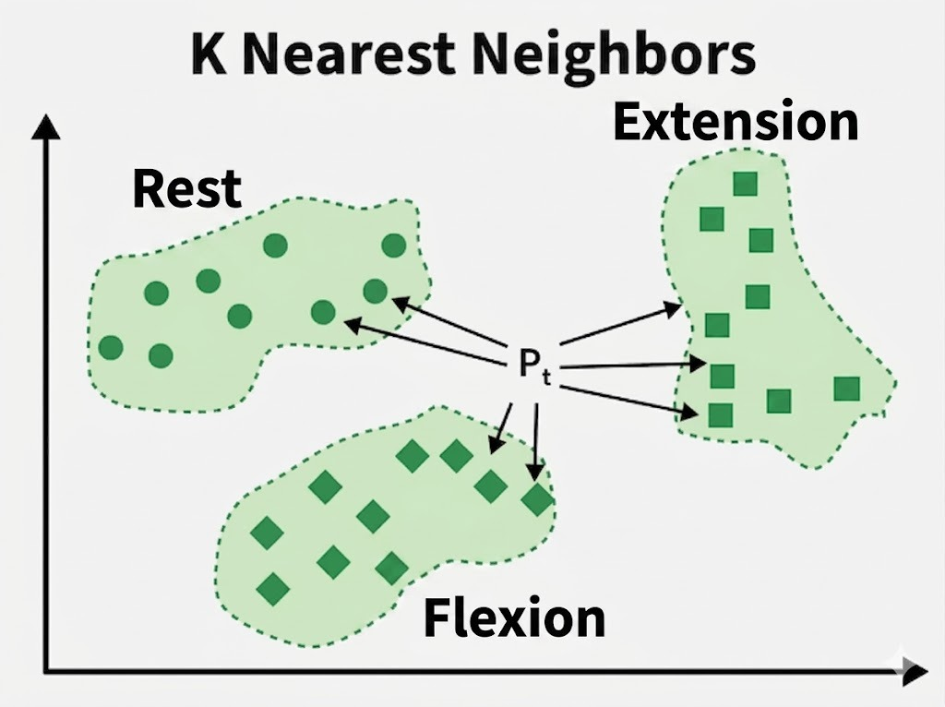
Figure 4.1: KNN Gesture Classification
The extracted features are passed to a K-Nearest Neighbours (KNN) classifier, which determines whether the signal corresponds to rest, flexion, or extension. To improve reliability, predictions are evaluated over multiple consecutive windows, reducing the effect of noise and unintended muscle activity.
4.2.3 Feedback and Logging
The classified gesture is mapped to actions in a graphical interface developed using Python. The interface responds to valid gestures by triggering movement or animation, providing immediate visual feedback to the user.
To avoid unstable responses, the system applies simple decision rules that ensure only consistent predictions result in output actions. At the same time, the system logs performance data such as repetition count and session duration, which can be used for further analysis.
4.3 KEY FEATURES OF THE PROPOSED SYSTEM
The system incorporates the following key features:

Robust Gesture Classification
Unlike basic threshold-based systems, the use of a machine learning classifier enables the system to distinguish between different gesture patterns more reliably, even in the presence of noise and signal variability.

Stable Real-Time Interaction
The inclusion of window-based processing and consistency checks ensures that the system responds only to deliberate muscle activity, minimizing false triggering and improving user experience.

Interactive Visual Feedback
The graphical interface provides immediate visual response to user actions, helping users understand their performance and maintain engagement during operation.

Performance Monitoring
The system records key session metrics, allowing basic evaluation of user performance and supporting future analysis or improvement of rehabilitation routines.

CHAPTER 5
HARDWARE IMPLEMENTATION
5.1 HARDWARE COMPONENTS USED
The hardware setup used for EMG signal acquisition and processing consists of the following components:
(i) Surface Ag/AgCl electrodes with snap connectors
(ii) Muscle Sensor module (analog front-end for EMG acquisition)
(iii) ESP32 microcontroller development board
(iv) Processing unit (PC for signal processing)
(v) Biopac MP150 system for reference signal observation
5.2 DESCRIPTION OF COMPONENTS
5.2.1 Surface Electrodes
Disposable Ag/AgCl electrodes are used to capture surface EMG signals from the forearm muscles. A bipolar electrode configuration is adopted, where two electrodes are placed along the muscle belly and a reference electrode is positioned on a bony region.
Proper skin preparation and electrode placement are essential to reduce impedance and improve signal quality [1].
5.2.2 Muscle Sensor Module (Analog Front-End)
The Muscle Sensor module serves as the analog front-end for EMG signal acquisition. It integrates amplification, rectification, and filtering stages required to process low-amplitude EMG signals.
The module provides:
- High-gain amplification of microvolt-level signals
- Basic filtering to reduce noise and motion artifacts
- Analog output proportional to muscle activation level
This simplifies hardware implementation by eliminating the need for a custom-designed analog front-end circuit. However, the output is an envelope signal, which limits access to detailed frequency-domain information compared to raw EMG acquisition.
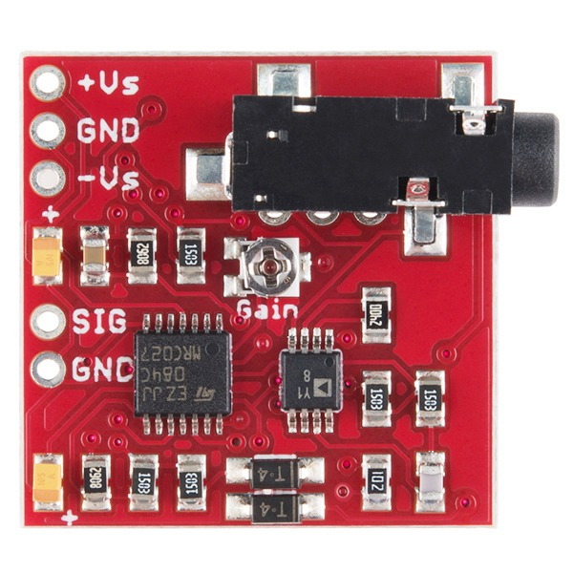
Figure 5.1: Muscle Sensor v3 module used as the analog front-end for EMG acquisition

5.2.3 ESP32 Microcontroller
The ESP32 microcontroller is used for digitizing the analog EMG signal obtained from the sensor module. It features an onboard ADC capable of sampling at sufficient rates for EMG signal acquisition.
The microcontroller reads analog values, timestamps them, and transmits the data to the processing unit via serial communication. Its processing capability and wireless support make it suitable for real-time embedded applications.

5.2.4 Processing Unit (PC)
The processing unit executes the signal processing and machine learning pipeline. It receives data from the ESP32 and performs:
- Signal normalization
- Windowing
- Feature extraction
- Gesture classification
Python-based libraries such as NumPy and Scikit-learn are used to implement the classification algorithm. This setup allows flexible development and testing of the model without the constraints of embedded hardware.

5.2.5 BIOPAC MP150 DAQ system
The Biopac MP150 system is a clinical-grade data acquisition platform used for recording physiological signals, including EMG. In this project, it may be used as a reference system to observe and validate EMG signal characteristics.
Compared to the Muscle Sensor module, the Biopac system provides higher precision, configurable filtering, and access to raw EMG signals, making it useful for benchmarking and analysis.
5.3 CIRCUIT DESIGN
The electrode leads are connected to the Muscle Sensor module, which outputs an analog voltage corresponding to muscle activity. This output is connected to an analog input pin of the ESP32.
Care is taken to:
- Minimize lead length to reduce noise pickup
- Avoid loose connections
- Ensure proper grounding
- These practices help improve signal quality and reduce interference [2]

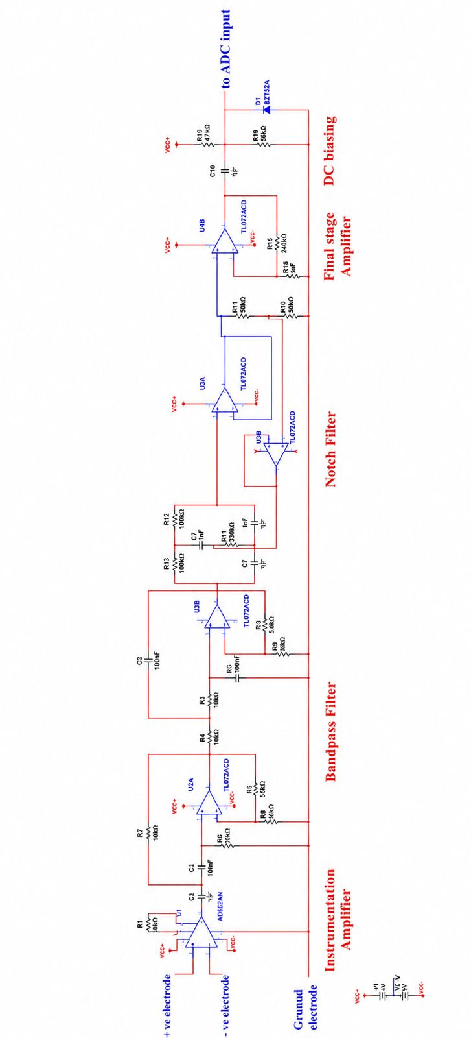
Figure 5.2: Analog front-end simulation circuit(instrumentation amplifier, bandpass filter, notch filter, final stage amplifier)

5.4 HARDWARE ARCHITECTURE
The hardware architecture follows a simple signal flow:
Electrodes → Muscle Sensor Module → ESP32 ADC → Processing Unit
During initial prototyping, a threshold-based system was implemented using the sensor output. This confirmed the feasibility of EMG-based gesture detection.The final setup retains the same acquisition hardware but integrates a software-based classification pipeline, enabling more reliable gesture recognition compared to simple thresholding. While the Muscle Sensor module provides ease of use, it outputs a processed envelope signal. As a result, the system primarily relies on time-domain features for classification rather than detailed spectral analysis.
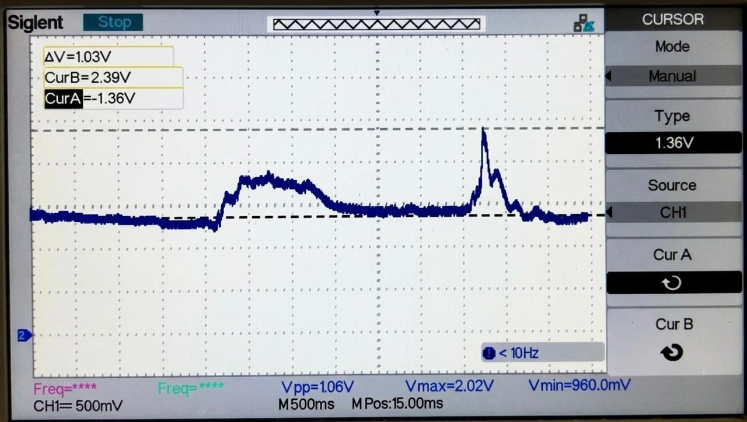
Figure 5.3: Oscilloscope output of the EMG sensor module showing muscle activation waveform (Vpp=1.06V, Vmax=2.02V)
Fig. 5.3 shows clear variations in EMG amplitude corresponding to muscle activity, with higher amplitudes during contraction. The waveform confirms successful EMG signal acquisition suitable for gesture classification.

CHAPTER 6
SOFTWARE IMPLEMENTATION
6.1 SOFTWARE TOOLS AND PLATFORMS
The software implementation is distributed across the embedded device and the processing system. The following tools and environments are used:
- C/C++(ArduinoIDE/ESP-IDF):
Used to program the ESP32 for analog signal acquisition, sampling control, and serial data transmission.
- Python (Processing System):
Used for signal processing, feature extraction, and real-time gesture classification. Libraries such as NumPy and Scikit-learn are used for numerical computation and machine learning implementation.
- Python Graphical Interface (Turtle/Pygame):
Used to visualize gesture-based control through simple interactive graphics during testing and operation.
6.2 ALGORITHM AND PROGRAM FLOW
The software pipeline operates in real time and consists of acquisition, preprocessing, feature extraction, classification, and output mapping.The ESP32 continuously samples the analog EMG signal and transmits the data stream to the processing system. The incoming signal is first normalized to reduce baseline drift and amplitude variation.
The normalized signal is segmented into overlapping time windows (typically 200 ms with 50% overlap). For each window, a feature vector is computed using time-domain descriptors such as:
- Mean value
- Mean Absolute Value (MAV)
- Root Mean Square (RMS)
- Standard deviation
- Maximum and minimum values
These features represent the intensity and variation of muscle activity within each window.The extracted feature vector is passed to a K-Nearest Neighbours (KNN) classifier, which compares it with stored training samples and assigns a label corresponding to one of three states: rest, flexion, or extension.
To improve robustness, classification outputs are evaluated over multiple consecutive windows. Only consistent predictions are considered valid, reducing false triggering due to noise or unintended movements.
The final gesture label is mapped to actions in the graphical interface, enabling real-time interaction.
6.3 SUMMARY OF SOFTWARE IMPLEMENTATION
The software implementation was developed in a staged manner to achieve reliable real-time EMG gesture classification. Initially, a threshold-based approach with a Python graphical interface was used to verify EMG signal responsiveness, electrode placement, and gesture-controlled interaction. The system was then upgraded to a feature-based processing framework in which normalized EMG signals were segmented into overlapping windows and analyzed using time-domain features such as mean value, MAV, RMS, standard deviation, and peak values. These extracted features were classified using a K-Nearest Neighbours (KNN) algorithm to identify rest, flexion, and extension gestures. Additional decision logic was incorporated to validate consecutive predictions, improving classification stability and reducing false triggering during real-time operation..

CHAPTER 7
RESULTS AND DISCUSSION
7.1 ML PIPELINE DEMONSTRATION
This appendix presents the complete operational workflow of the EMG-based gesture recognition system, from signal acquisition and CSV generation in VS Code to real-time gesture classification via the launcher application. Screenshots of each stage are included below to illustrate the system in operation.
7.1.1 System Workflow Overview
The complete pipeline begins with the ESP32 hardware module, which performs analog rectification and hardware filtering on the raw EMG signal. A Python script running in VS Code reads the serial output of the module at 1000 Hz and logs the data into a CSV file. This CSV file is then loaded into the EMG Turtle Launcher application, which runs the trained KNN classifier. Based on the predicted gesture (Flexion, Extension, or Rest), the application moves the Turtle character upward, downward, or keeps it stationary.
7.1.2 Application Launcher
The EMG Hardware Gesture Replay launcher provides a simple interface for the user to select a recorded CSV file and launch the gesture control session. The user browses for the CSV file generated by the VS Code data collection script and clicks “Launch Turtle” to start the classification pipeline.
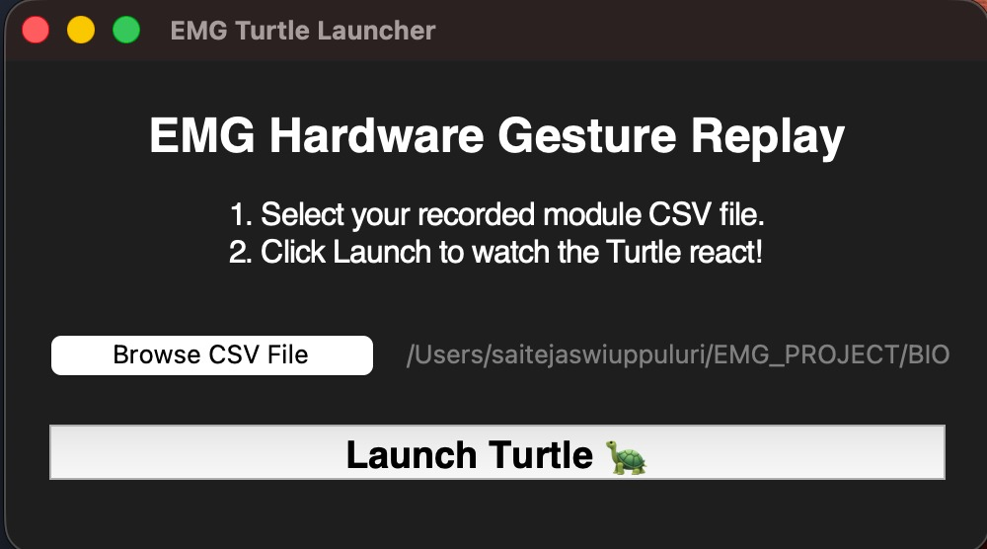
Figure 7.1: EMG Hardware Gesture Replay launcher application.
7.1.3 Game Window (EMG Gesture Control)
Once launched, the EMG Gesture Control window displays real-time prediction output. The window shows three fields: Prediction (the raw KNN output), Action (the final gate-filtered command sent to the Turtle), and Confidence (the probability margin of the winning prediction). The Turtle moves upward on Extension, downward on Flexion, and remains stationary during Rest.
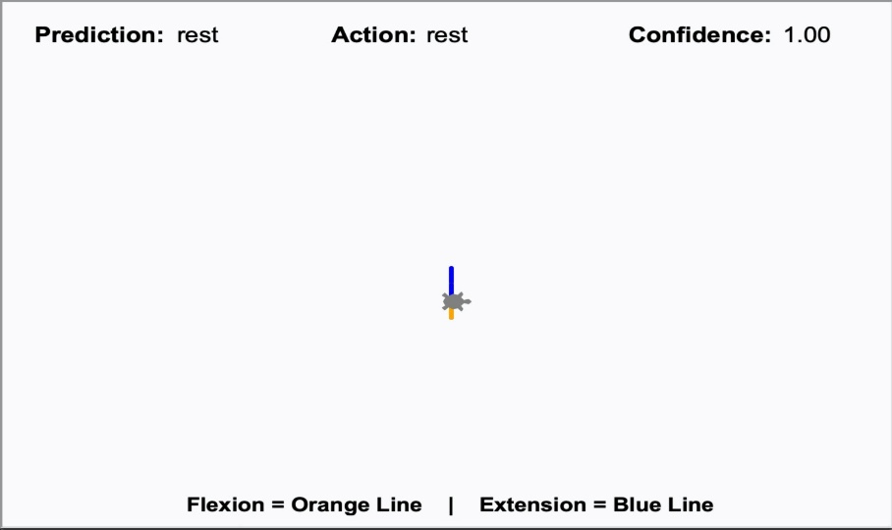
Figure 7.2: EMG Gesture Control window showing Turtle in rest state with confidence 1.00.
7.1.4 Session Terminal Log
After the session ends, the terminal displays a timestamped log of all TRIGGER events. Each entry records the time (in seconds from session start), the predicted gesture, the KNN confidence score, the margin between the top two votes, and the Euclidean distance from the nearest training sample. This log allows for post-session review and validation of the system’s real-time performance.
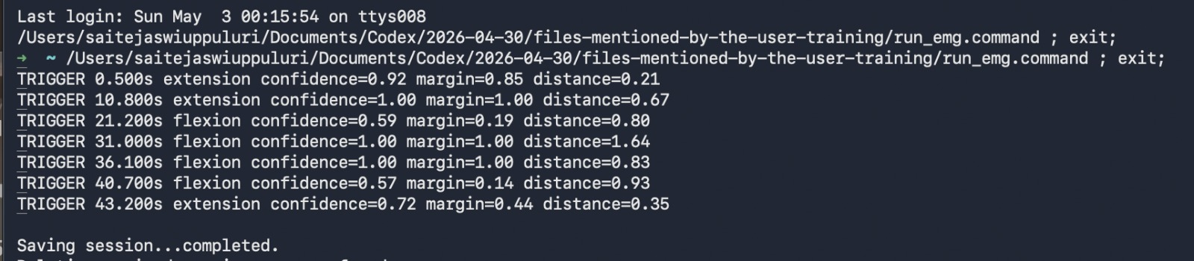
Figure 7.3: Post-session terminal log showing timestamped predicted gestures with confidence and margin values.
7.1.5 Confusion Matrix (Validation Results)
As shown in Fig. 7.4, the confusion matrix presents the model’s performance across 144 validation windows during LOFO cross-validation. The model achieves perfect specificity for the Rest state (72/72 correct), with only minor misclassifications between Flexion and Extension gestures. The implemented safety logic reduces false positive activations during real-time operation.
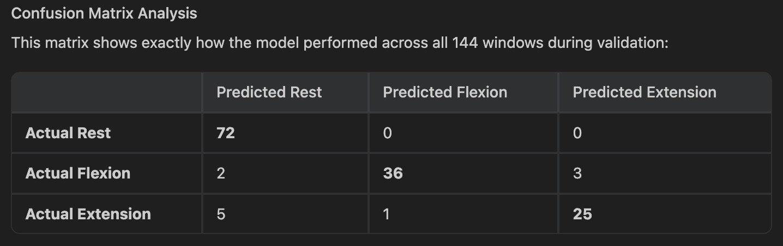
Figure 7.4: Confusion matrix showing classification results across 144 validation windows.
7.2 MODULE DATA VISUALISATION
The graph below shows the rectified and filtered EMG signal produced by the ESP32 hardware module, plotted as voltage versus time. Clear activation spikes corresponding to deliberate Flexion and Extension gestures are visible, rising significantly above the baseline rest level. This hardware-filtered, positive-envelope signal is the direct input to the Python preprocessing and feature extraction pipeline.
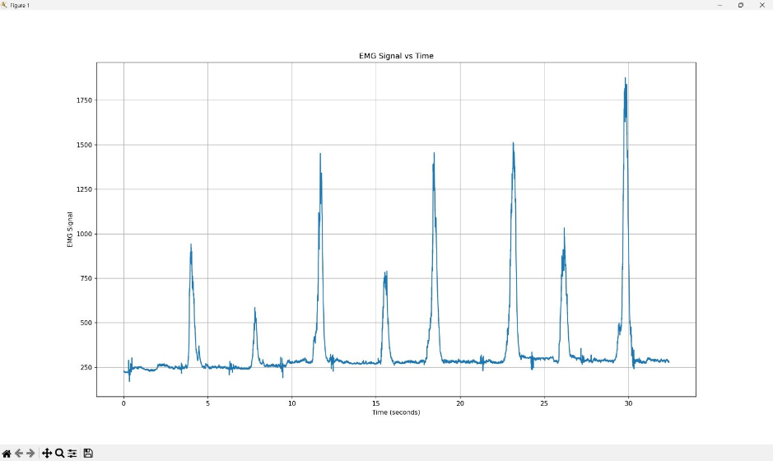
Figure 7.5: Rectified, filtered EMG signal vs. time, showing distinct activation spikes during gestures.
7.3 Raw EMG Signal and RMS Envelope (AcqKnowledge)
Fig. 7.6 shows the raw EMG signal (red) and corresponding RMS envelope (blue) captured using AcqKnowledge software. Unlike the rectified hardware output used in this project, the raw EMG signal oscillates around zero, while the RMS envelope clearly highlights muscle activation regions for gesture analysis.
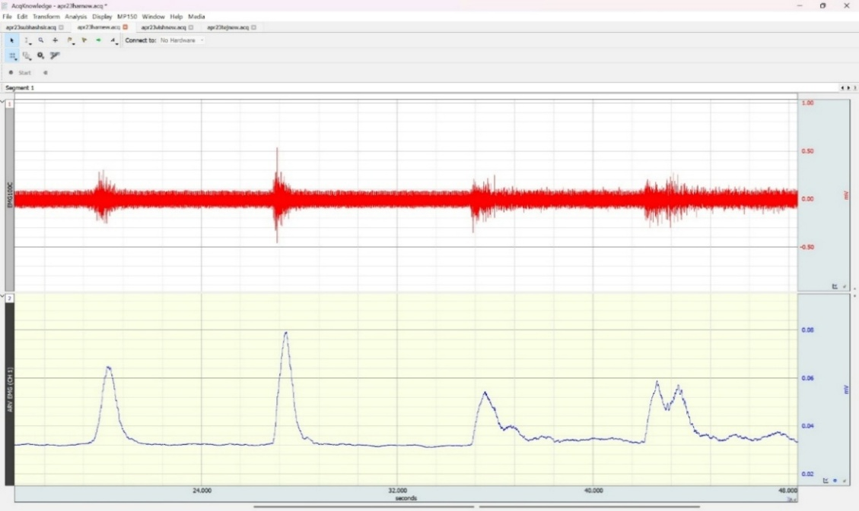
Figure 7.6: Raw EMG signal (red) and RMS envelope (blue) captured in AcqKnowledge for reference.
The comparision between raw EMG and ARV signals envelope signals demonstrate the effectiveness of envelope-based processing for identifying muscle activation.

CHAPTER 8
CONCLUSION AND FUTURE SCOPE
8.1 CONCLUSION
- Successfully interfaced the EMG sensor module with the ESP32 for upper limb muscle activity acquisition..
- Acquired and analyzed EMG signals corresponding to flexion and extension gestures.
- Applied normalization techniques to eliminate amplitude variations, ensuring hardware-independent performance across different acquisition systems.
- Extracted time-domain features (RMS, MAV) that effectively represent muscle activation levels for gesture discrimination.
- Implemented a machine learning-based classification model capable of reliably distinguishing between flexion and extension gestures.
- Achieved consistent and real-time gesture recognition, demonstrating the feasibility of EMG signals for interactive control applications.
- Established the initial framework for real-time gesture classification and rehabilitation-based interaction using EMG signals.

8.2 FUTURE SCOPE
1. Advanced Analog Front-End Design
Design and optimize a dedicated EMG analog front-end using instrumentation amplifiers (AD620) with proper gain control and noise filtering to improve signal quality and reliability.

2. Custom PCB Development
Develop a compact and integrated PCB for EMG acquisition and signal conditioning to reduce noise, improve stability, and enable a portable and wearable system.

3. Multi-Gesture Recognition
Extend the system beyond basic flexion and extension to detect multiple complex gestures using multi-channel EMG signals and enhanced feature extraction techniques.

4. Improved Signal Conditioning
Further refine amplification and filtering stages (HPF, LPF, notch) to reduce motion artifacts and power line interference, ensuring consistent and accurate signal acquisition.

5. Advanced Machine Learning Integration
Implement advanced classification models such as SVM, Random Forest, or Neural Networks to improve accuracy and enable adaptive, user-specific gesture recognition.

6. Enhanced Real-Time Rehabilitation Gaming
Expand the Unity-based rehabilitation system to include real-time feedback, repetition tracking, adaptive difficulty levels, and performance evaluation metrics for improved user engagement.

APPENDIX
A.1 Extraction of seven statistical features from raw EMG signal
windows for machine learning classification.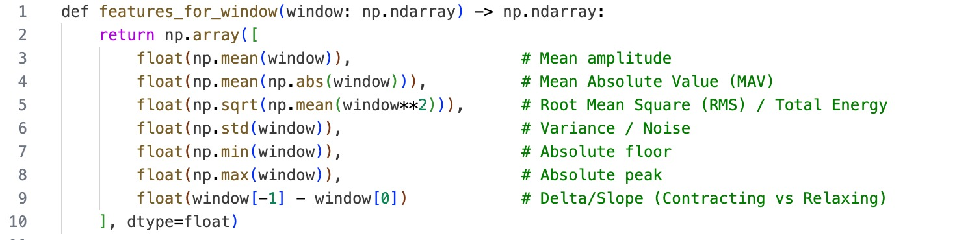
Figure A1: EMG Feature Extraction Function
This function converts a raw EMG signal window into a compact set of numerical features suitable for machine learning.
Statistical parameters such as Mean, Mean Absolute Value (MAV), RMS, Standard Deviation, Minimum, Maximum, and Signal Slope are extracted.
These features represent muscle activity intensity, energy, variation, and signal trend.
The extracted feature vector forms the input to the classification algorithm for gesture recognition.
A.2 Standardization of extracted EMG features using mean and
standard deviation for balanced model performance.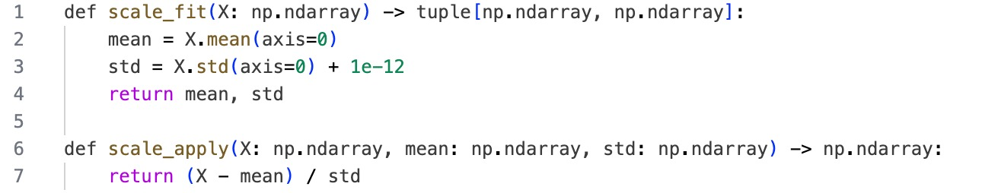
Figure A.2: Z-Score Normalization and Feature Scaling
This module performs feature normalization using the mean and standard deviation of the training dataset.
Z-score scaling ensures that all extracted EMG features are brought to a common numerical range.
The process prevents high-magnitude features from dominating the machine learning calculations.
Normalized data improves classification stability, accuracy, and real-time prediction consistency.
A.3 Custom K-Nearest Neighbors (KNN) model with weighted voting and safety thresholds for real-time EMG gesture prediction.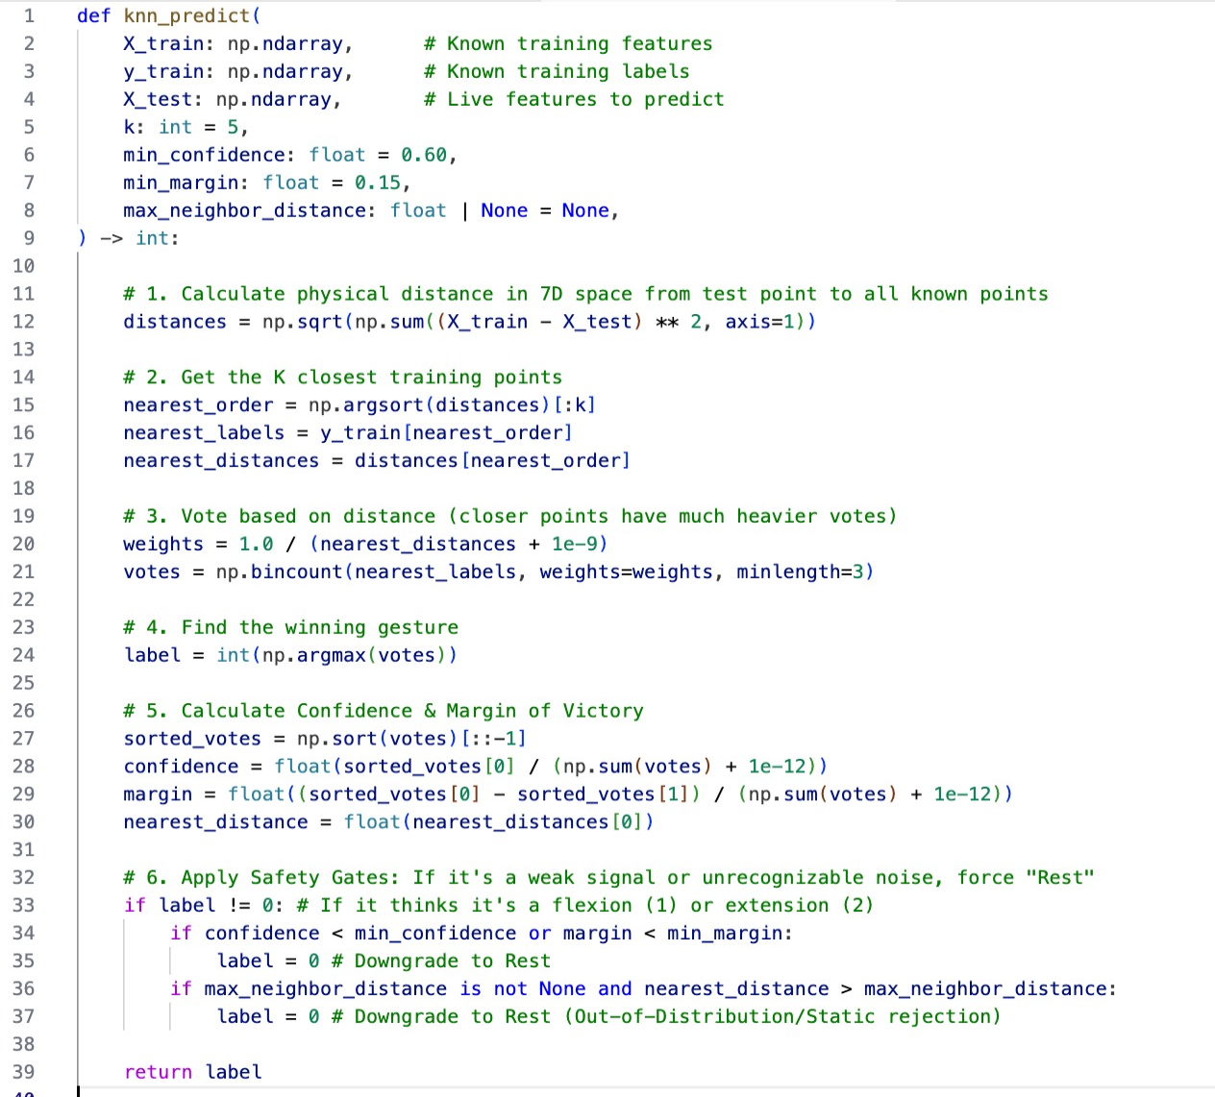
Figure A.3: Distance-Weighted KNN Classification Algorithm
This figure shows the implementation of the custom Distance-Weighted K-Nearest Neighbors (KNN) classifier used for EMG gesture prediction.
The algorithm computes Euclidean distances between live EMG feature vectors and labeled training samples in multi-dimensional feature space.
Closer neighbors are assigned higher voting weights to improve prediction reliability and responsiveness.
Additional confidence, margin, and distance-based safety checks are included to reject weak or noisy muscle signals and improve classification robustness.

A.4 Real-Time EMG Data Acquisition Using ESP32
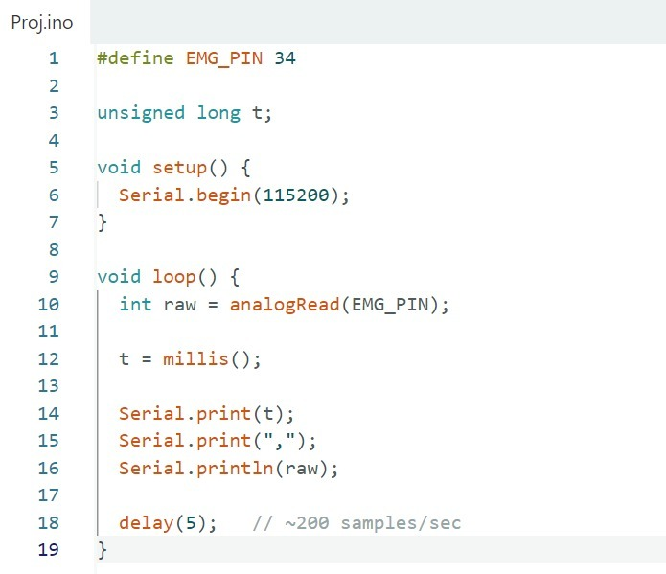
Figure A.4: ESP32-based real-time EMG signal acquisition and serial data transmission setup.

The ESP32 continuously samples the EMG signal from the analog input pin at an approximate rate of 200 samples per second. Each sample is timestamped using the internal millisecond counter, ensuring proper temporal alignment of the signal. The acquired data is transmitted via serial communication in a structured format (time, raw EMG value). This setup provides a reliable and low-latency method for capturing muscle activity in real time. The simplicity of the code ensures consistent sampling without computational overhead.

A.5 EMG Signal Visualization Using Python
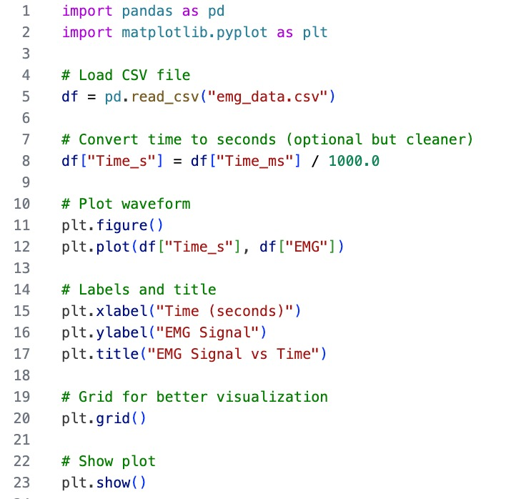
Fig. A.5: Python-based EMG data visualization from CSV using Pandas and Matplotlib.
The recorded EMG data is visualized using Python libraries such as Pandas and Matplotlib. The time-domain waveform provides clear insight into muscle activation patterns, including amplitude variations and signal noise. Grid and labeling enhancements improve interpretability of the signal characteristics. Visualization helps in identifying distinct patterns corresponding to different gestures. This step acts as a validation stage before feeding the data into the machine learning model.

REFERENCES
[1] L. McManus, G. De Vito, and M. M. Lowery,“Analysis and Biophysics of Surface
EMG for Physiotherapists and Kinesiologists: Toward a Common Language With
Rehabilitation Engineers,” Frontiers in Neurology, vol. 11, Art. no. 576729, 2020.

[2] J.-H. Sul, L. Piyathilaka, D. Moratuwage, R. Ranasinghe, and M. Mohanraj,
“Electromyography Signal Acquisition, Filtering, and Data Analysis for Exoskeleton
Development,” Sensors, vol. 25, no. 13, Art. no. 4004, 2025.

[3] C. Schlüter, M. R. Hossain, M. S. Islam, and A. K. M. Fazlul Haque, “Development
of a Low-Cost EMG Data Acquisition Armband to Control an Above-Elbow
Prosthesis,” Journal of Physics: Conference Series, vol. 2167,no.1,2022.

[4] E. D. Oña, S. Marcos-Antón, D. S. Copaci, J. Arias, R. Cano-de-la-Cuerda, and
A.Jardón, “Effects of EMG-Controlled Video Games on the Upper Limb
Functionality in Patients with Multiple Sclerosis: A Feasibility Study,”
Computational Intelligence and Neuroscience, vol. 2022, Art. no. 3735979, 2022.

[5] M. Santos Pessoa de Melo, J. Gomes da Silva Neto, J. M. X. Natário Teixeira,
A. E. Fontes da Gama, and V. Teichrieb,“An EMG-Based Virtual Reality
Application for Motor Rehabilitation,” in Proceedings of the 21st Symposium on
Virtual and Augmented Reality (SVR), Rio de Janeiro, Brazil, 2019, pp. 170–177.

[6] C. Vo Duy,“Design and Development of a Wrist Rehabilitation Device with an
Interactive Game,” Results in Engineering, vol. 22, Art. no. 102336, 2024.

[7] D. Farina, R. Merletti, and D. Stegeman,“Biophysics of the Generation of EMG
Signals,” in Electromyography: Physiology, Engineering, and Non-invasive
Applications, Piscataway, NJ, USA: IEEE Press, 2004, pp. 81–105

[8] P. E. Barkhaus and S. D. Nandedkar,“EMG Evaluation of the Motor Unit—
Electrophysiologic Biopsy,” eMedicine Journal, 2020.

